**COE 768: Mid-Term Test**

**2014**

* There are **Four** questions. Answer **ALL** of them. The points assigned to the questions are indicated at the beginning of the questions. The total points of this paper are 100.
* If doubt exists as to the interpretation of any question, the student is urged to submit with the answer paper, a clear statement of any assumption made.
* Time limit: 1 hours.

**Student Name:**

**Student ID:**

|  |  |
| --- | --- |
| **Question** | **Marks** |
| Question 1 (30%) |  |
| Question 2 (25%) |  |
| Question 3 (20%) |  |
| Question 4 (25%) |  |
| **Total**  **(100%)** |  |

**Problem 1 (30 points)**

Consider the connection between two stations as illustrated in the following figure. The protocol stack has five layers. The figure also shows the PDU formats of the transport, network and data-link layers.

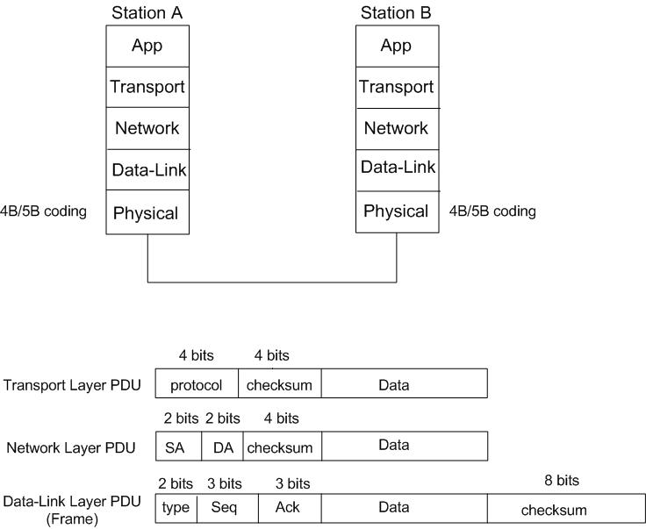

In the Network layer PDU, SA and DA stand for source and destination network addresses, respectively. The transport and network layers use 1’s complement to derive the checksum. The checksum used in the transport layer will check the transmission error of the complete PDU while the checksum used in the network layer is used to check the transmission error in the PDU header only. The data-link layer uses CRC to compute the checksum. The generator polynomial for the CRC is G(x) = x8+x2+x+1. The 2-bit type field of the Data-link layer PDU has the value of 10 (in binary). The protocol field of the transport PDU is set to 1000 (in binary) to identify the application running at the application layer. Finally, the data-link PDU is encoded by 4B/5B with NRZ-I / MLT-3 coding for transmission.

Suppose station B received two Frames from A. The content of the two frames are shown:

* Frame one: 10001100 01101001 10000010 10101010 10010011
* Frame two: 10010100 01101001 10001011 10110000 11100101

Frame one was received before frame two.

1. **(5 points)** Based on the frame information, determine the network addresses of stations A and B.
2. **(5 points)** Sketch the NRZI/MLT-3 waveform of the **frame header** of frame 1, assuming the signal level of the first bit of the header is negative.
3. **(20 points)** Suppose the window statuses of Station B before the reception of frame one are:
   * S*n* = 4, S*f* = 4, R*n*=2

Determine which frame (if any) would be rejected by one of the layers (Data-link, Network or Transport layer) of station B. **Assume that both frames passed the CRC check at the data-link layer.** Show all the steps to support your answer.

**Problem 2**

1. **(15 points)** Consider the following point-to-multipoint configuration:

Primary

Station

**B**

**A**

Secondary Stations Stations

The time diagram below illustrates the frame exchanges between the primary station and the secondary stations using HDLC normal response mode with Selective-Repeat protocol.

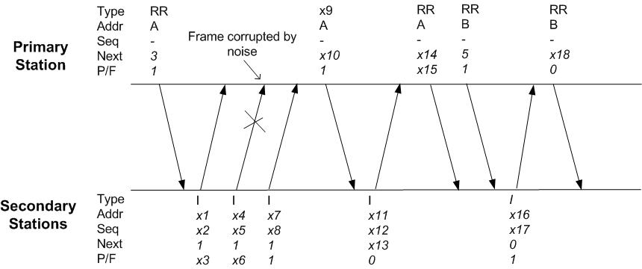

Each frame carries a type field (Type), address field (Addr), next field (Next), the P/F bit, and possibly the sequence number field (Seq). The diagram shows the values in some of the fields. Assume all the windows of the stations are synchronized initially and all the frames, except one, are received correctly. Determine the unknown values in the diagram, from *x1* to *x18.*

1. **(10 points)** Two stations A and B are negotiating to setup a PPP link. Station A wants to setup the following LCP parameters:
   * MRU=1500 bytes; Authentication = CHAP; No Header compression.

Suppose station A receives an LCP_requst packet from station B with the following content:

* MRU=1000 bytes; Authentication=CHAP; Header compression

Sketch the time diagram to illustrate the subsequent LCP exchange between stations A and B for the scenario in which the negotiation is successful. In the time diagram, you should clearly indicate the type and the content of each LCP packets.

**Problem 3 (20 points)**

You are requested to design a communication system that supports the communications between two high-end servers over a physical link which is fairly reliable but will introduce transmission error, approximately 1 bit error per 106 bits of transmission. The following are the link parameters:

* One-way signal propagation delay = 1 msec.
* Channel data rate = 100 Mbps;

The main goal of your design is to maximize the link efficiency. Consider the following points in your design:

* Error-Control protocol – Choose one of the three connection-oriented error control protocols: Stop-and-Wait, Go-Back-n and Selective Repeat.
* Maximum frame size (including frame header and FCS) – Choose one of the following frame sizes: 256 bytes, 512 bytes, 1024 bytes.
* The number of bits used for sequence number field in the data frames.

You **must provide enough justifications** to support your design.

**Problem 4 (25 points)**

Design and write an application (both client and server) where the server saves the messages typed by the user at the user’s terminal. The message will be saved in a file whose name is specified by the user. The following time diagram illustrates the protocol of the application.

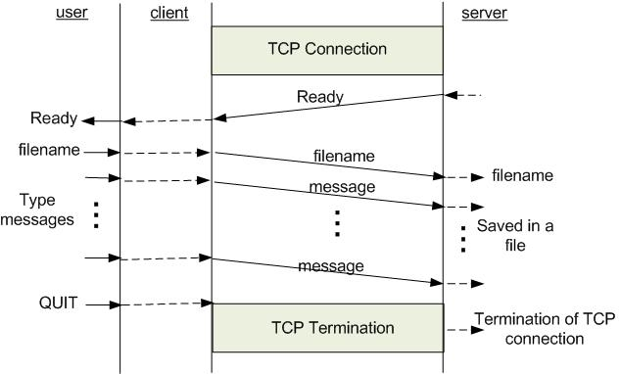

As illustrated in the diagram, the server will send a “Ready” message to the client after the TCP connection is established. The client then notifies the user that the server is ready. The user responds by inputting a file name to be used by the server to save the user’s messages. After that, any messages typed in the terminal will be sent to the server for saving. The user can quit the service by just typing “QUIT”.

**Do not** include the code associated with the establishment of the TCP connection.